1. How many pods exist on the system?

2- How many Nodes exist on the system?



3- Create a new pod with the nginx image.

Image name: nginx

4- Which nodes are these pods placed on?

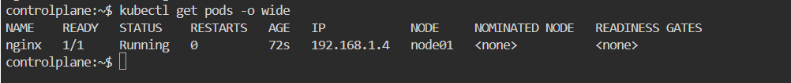

5- Create pod from the below yaml using kubectl apply command

apiVersion: v1

kind: Pod

metadata:

name: webapp

namespace: default

spec:

containers:

- image: nginx

imagePullPolicy: Always

name: nginx

- image: agentx

imagePullPolicy: Always

name: agentx

6- How many containers are part of the pod webapp

2 Contianers 1 Ready 1 ErrImagePull

7- What images are used in the new webapp pod?

kubectl describe pod webapp

8- What is the state of the container agentx in the pod webapp

The agentx container is likely in an **Error** or **CrashLoopBackOff** state.

9- Why do you think the container agentx in pod webapp is in error?

The agentx container is in error because the agentx image does not exist in any accessible registry.

10- Delete the webapp Pod.

11- Create a new pod with the name redis and with the image redis123.

* Name: redis
* Image Name: redis123

The redis123 image does not exist on Docker Hub, so the pod will likely fail with an ImagePullBackOff error. If you meant redis, use that instead (see question 12).

12- Now change the image on this pod to redis.

Once done, the pod should be in a running state.

13- Create a pod called my-pod of image nginx:alpine

14- Delete the pod called my-pod

